Lab 9. Analysis of revenue in sales dataset

i) Create a choropleth map (fill the map) to spot the special trends to show the state revenue.
ii) Create a line chart to show the revenue based on the month of the year.
iii) Create a bin of size 10 for the age measure to create a new dimension to show the revenue.
iv) Create a donut chart view to show the percentage of revenue per region by creating zero access in the calculated field.
v) Create a butterfly chart by reversing the bar chart to compare female & male revenue based on product category.
vi) Create a calculated field to show the average revenue per state & display profitable & non-profitable state.
vii) Build a dashboard.

vi) Create a calculated field to show the average revenue per state & display profitable & non-profitable state.

To create a calculated field that shows the average revenue per state and categorize each state as profitable or non-profitable, we shall create two measures:
- one to calculate the average revenue per state and
- Another, to categorize each state as profitable or non-profitable based on a defined threshold.

Step 1: Calculate Average Revenue Per State
- Go to the Data/Fields Pane:
- In Power BI, locate the table that contains your Revenue and State columns.
- Create a New Measure for Average Revenue Per State:
- Right Click and select New Measure.
- In the formula bar, type the following DAX formula to calculate the average revenue per state and press Enter key.
Average Revenue Per State = AVERAGE('Sheet1'[Revenue])

- Display Average Revenue Per State on a Card
- Go to the Report View.
- From the Visualizations pane, select the Card visual.
- Drag the Average Revenue Per State measure to the Fields section of the Card visual.
- Format the Card to display the revenue neatly.
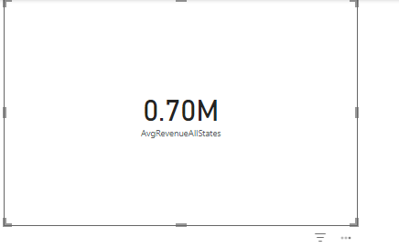
- Create a Calculated Field to Identify Profitable and Non-Profitable States
- In the Home Tab, Select → New Column.
- Enter the following formula:
ProfitabilityStatus = IF(CALCULATE(SUM(Sheet1[Revenue])) < 600000, "Non-Profitable", "Profitable")
